**Cuizine:**

Nihari

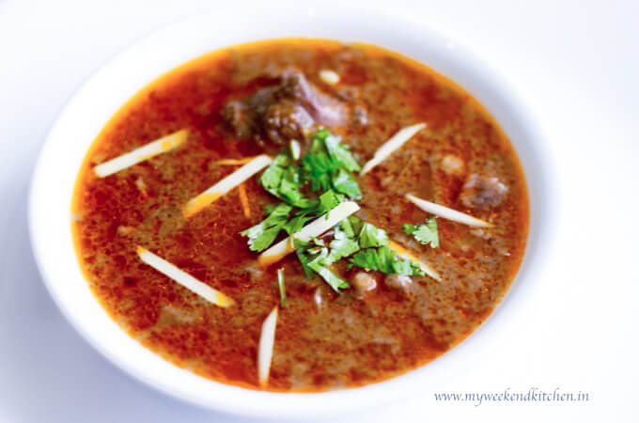

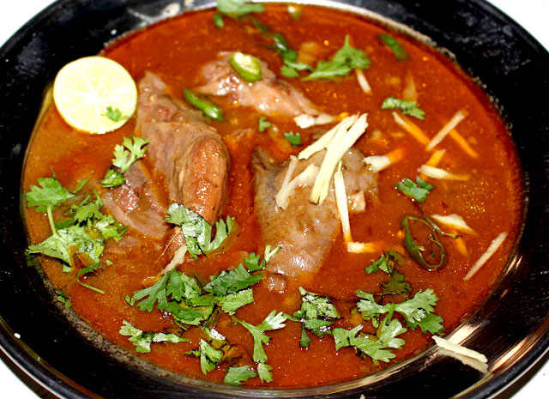

**Nihari** is a stew from the Indian subcontinent consisting of slow-cooked meat mainly shank meat of beef or lamb and mutton, goat meat and chicken, along with bone marrow. Nihari developed with the overall cuisine of Muslims of the Indian subcontinent. It has been an old popular delicacy in parts of Bangladesh, particularly Dhaka and Chittagong. People cooked it for one whole night and they got it in the early morning at sunrise. It is a popular dish and is regarded as the national dish of Pakistan.